Phoenix Pho

Wentworth Institute of Technology

Database

2650

Nguyen Thai

02/04/2021

Dan Tran - Tommy Nguyen

Vietnamese foods have a distinct but delicious taste that has become known throughout the world. Phoenix Pho is one of many restaurants that specializes in Vietnamese foods. Phoenix Pho is a 5-star restaurant that excels in traditional Vietnamese cuisines such as Pho, Goi cuon, Banh khot, and Banh mi. Phoenix Pho’s menu is wide and varied, but its specialty is Pho. Phoenix Pho provides a variety of Pho from Hanoi-style pho to Phở Áp Chảo Gìon (crispy fried pho noodles with beef), Phoenix Pho’s Pho can come in many forms. Phoenix Pho provides nothing but the best food services and food quality. While their food is being prepared, Phoenix Pho provides appetizers for the customers in the meantime. Throughout their time in Phoenix Pho, calm and traditional Vietnamese music are played in the background to foster the cultural atmosphere and environment of Phoenix Pho.

Phoenix Pho takes pride in its quick and efficient waiter/waitress response. Phoenix Pho’s employees are an exceptional group who prioritizes customer satisfaction over all else. In particular, the employees are taught to respond to customer requests or questions as quickly as they possibly can (it is understandable that this cannot always be the case). Phoenix Pho has numerous employees during each opening and can handle in situations where the restaurant is packed and full. In addition to the customer services, numerous traditional Vietnamese arts are placed throughout the restaurant in order to further drag out the traditional feel of the restaurant.

## **(1)** Phoenix Pho is a restaurant that provides traditional Vietnamese food. Some of the main things we offer include Cơm (Rice Dishes), Bún (Rice Vermicelli Noodle Bowl), Bánh Mì (Vietnamese Sandwiches), and of course, Pho (soup noodles).Each of these comes in a variety of different forms as one customer may prefer to have seafood, another may prefer meat, or someone might want a little of both. They can also choose whether they want sauce or not (sauces can be seasoning, spices, or condiments) or if they want vegetables with their dishes. There are many different combinations or ways that these dishes can be served. As a result, our vast dishes contribute/help with dietary restrictions that many customers may have. Our restaurant also provides appetizers, such as spring rolls and crab ragoon, and drinks such as coffee, soft drinks, and smoothies.

In our store, we own all the facilities and equipment we use to store ingredients and prepare our food. We have a large storage area, equipped with freezers, shelves and containers in order to store all the items we use. In addition, we also have kitchens where we store our cooking utensils so that we do not need to exit the kitchen in order to get necessary tools. Many of our kitchens have storage areas within them, but there are certain Phoenix Pho areas where the storage area and kitchen are separate. We regularly clean these areas to ensure that none of our food, storage areas, or cooking tools (such as utensils or machinery) gets contaminated by anything. We also do this for our machinery and tools, such as our stoves, grills, fryers, and utensils. We keep track of each time an employee cleans a storage area, kitchen, or utensils by making sure they track their time and write down their employee ID to let us know who cleaned what and when. Every Phoenix Pho restaurant contains all necessary cooking utilities, utensils, storage utilities, storage areas, and cleaning tools needed to maintain a clean and healthy environment as well as fresh and healthy foods for our guests.

The employees in our store are a mixture of both part-time and full-time employees. For our waiters and waitresses, as well as our cashiers, they can either be full-time or part-time. Of course, the longer someone stays working for us, the more benefits they will receive from us, such as more paid vacations and higher salary. For our chefs, we mostly only hire full-time chefs. This is because chefs are the core part of our restaurant, without them, we cannot possibly operate. That is why we would like to only hire people that we know will not quit at a moment’s notice and are committed to staying. Of course, if there is a lack of manpower in the kitchen, we are not opposed to hire chefs who want to only work-part time. Our employees and finances are managed by a financial advisor who manages the information about employee pay, business cost, and etc in an excel sheet that gets continuously updated based on pay raise, cost increase/decrease, and so forth. The financial advisor for Phoenix Pho is responsible for managing Phoenix Pho’s finance as well as employee pay. Constant communication with financial advisor for Phoenix Pho is required in order to maintain accurate information of the current state of the business and/or employees. Additionally, we have managers who watch over and check up on the employees to see how they are doing or their progress for a specific dish. Every manager needs to watch/manage at least 1 employee and an employee must be managed by and report to 1 manager. Furthermore, if our employees apply for one opportunity at one location, they are able to work at other Phoenix Pho locations as well.

**(2)** Due to the nature of our food, we need to buy certain items or ingredients in order to make our dishes. Some of the more important items are rice, noodles, and vermicelli, as many of our main dishes depend on these core ingredients. Other things that we must buy are seafood, meat, and spices/seasoning. Each of the items on our menu are served at all our stores. Whether it be the appetizers, lunches, or dinners, we do not exclude anything from any menu. All of the dishes that we serve are all prepared in their respective stores (and as such, means that all of our employees do not work in a single store, but our employment spreads to multiple stores across the country and world). We do not believe in pre-cooking a dish and then shipping it out to a store to serve. Everything a customer orders is freshly cooked and served with care.

While we do not provide catering, we do provide our customers with take-out if they so wish. They can use our online website so that they can place their order. We accept both cash and credit. If they choose to pay in credit, they have many different options for their payment method on our site. If they choose to pay in cash, they can pay once they come to pick up their order. Our site not only lets customers order take-out, it also lets customers place an online reservation. All they would need to do is select a time that is available and then designate the amount of people in their party. If they need any special accommodations, they can let us know in the ‘Notes’ section when placing the reservation and we will try our best to meet their needs. Phoenix Pho handles special dietary restriction by providing a menu that contains foods for those with dietary restrictions or allergies. The menu is not abundant meaning that customers are open to giving possible new foods for any dietary restrictions.

**(3):** Phoenix Pho is a restaurant that is located across the world, but it’s central/original restaurant resides in Boston Massachusetts. The buildings that the restaurants are occupying was not rented but bought. As a result, the restaurants need to pay monthly mortgages with some interest. However, the owner had chosen to buy the building instead of renting because of the long-term benefits of buying rather than renting. Unlike renting, buying does not have a fluctuating price. Instead, buying the building only requires a monthly mortgage payment; renting buildings would not ensure a stable monthly/bi-monthly payment, resulting in the restaurant accumulating more fees and payments in the long run. Additionally, buying buildings would ensure that the buildings do not have an expiring lease. Comparatively, Phoenix Pho seems to have a higher total cost than most other restaurants (when talking about the cost for the building alone). However, that is only looking at the short-term impact of buying buildings for Phoenix Pho. In the long run, buying buildings will certainly result in a lower payment compared to other restaurants who rent a building. In order to minimize the cost as a result of buying buildings, Phoenix Pho does not pay for customers parking space if Phoenix Pho does not have a parking space. Phoenix Pho does have parking space, but if the parking space is full, customers will have to find parking spaces of their own at their own cost or come at some other time.

Phoenix Pho’s ingredients and supplies are bought with the money that is used for the business. After all, ingredients and supplies to prep food are necessary for the operation of Phoenix Pho and as such are considered business necessities. However, the cost for ingredients is relatively low compared to most other restaurants as a result of the ingredients being locally bought from small Vietnamese businesses. Because Phoenix Pho requires ingredients only found in Vietnam (and are bought by businesses in America), some of Phoenix Pho’s essential ingredients are dependent on the political climate and possible political conflict between the US and Vietnam. In turn, if the US and Vietnam were to get into conflict in the foreseeable future and possibly close trades, then Phoenix Pho will have to find alternatives for those resources/ingredients. As for weather dependent, many of our ingredients can be stored in our freezers which preserves them for future uses (lasting months). In turn, Phoenix Pho usually buys their ingredients ahead of time and stores them in case the ingredient is needed for a food. Buying ingredients and buildings for Phoenix Pho is costly, but what is more important is employee payment. As stated prior, chefs are necessary for the operation of Phoenix Pho. As such, the pay for chefs is higher than other roles. Phoenix Pho is committed to employing loyal and long staying chefs. In turn, Phoenix Pho provides many benefits towards these employees (specifically chefs) to draw in talent and loyalty to Phoenix Pho. There are other expenses that are necessary for the operation of Phoenix Pho. For example, maintance (when a restaurant requires some changes or fixes that are caused by malfunctions and etc), employee pay, and so forth.

**(4)** Phoenix Pho operates like many restaurants, it is open on both weekdays and weekends. During the weekdays, Phoenix Pho’s employees are mainly full-time employees, with a few being part-time. Alternatively, on weekends it is mainly part-time employees with a few being full-time. The employees for Phoenix Pho rotate based on schedule and do not work throughout the entire week (7 days). Instead, different employees work on weekends and different employees work on weekdays (unless chosen otherwise by the employee). Some of Phoenix Pho’s restaurants are not able to operate like this. As a result, those Phoenix Pho’s restaurants operate only on business days within business districts (as operating on business days draws in more customers and lasts for a longer duration, 5 days instead of just 2).

Phoenix Pho is not a seasonal restaurant. Instead, Phoenix Pho is a traditional restaurant that aspires to spread Vietnamese culture all throughout the year. As such, Phoenix Pho operates on most holidays with a few exceptions (national holidays). During most holidays, Phoenix Pho gains a lot of customers as a result of its exquisite foods. In turn, Phoenix Pho gains profit as a result of operating on holidays where many people are on break and/or going on vacation.

**(5)** Phoenix Pho opens from 10 AM and closes at 10 PM. Juxtaposing to many other restaurants, Phoenix Pho’s operation time is normal. Phoenix Pho receives the most customers between 12 PM – 2 PM and 5 PM – 8 PM. The reason for the abundant of customers during this time is because 12 PM is when many usually take their lunch break, and 5 PM is normally the time people usually gets off work. In turn, Phoenix Pho’s late schedule gives it an advantage in drawing in customers and gaining profit.

In order to balance out the cost of providing many special offers year-round, and the cost of purchasing high quality ingredients, Phoenix Pho’s prices are slightly higher than the average prices of other similar restaurants. While higher than usual prices may deter first time customers, Phoenix Pho provides many special deals for its loyal and longtime customers. For example, on holidays, Phoenix Pho provides a 20 percent off any menu item for customers who have recently ate at the restaurant before. Phoenix Pho manages which customer visits for this deal based on a punch card given by the restaurant to the customer after visiting on a holiday. The punch card contains the date, specific holidays, and a signature that differentiate it from a false punch card. Another thing that sets Phoenix Pho apart from its competitors is that it also has a bar in its restaurant. The bar opens at 5PM and closes at 10PM. At this bar, customers may order a variety of different snacks, appetizers, and drinks (both alcoholic and non-alcoholic). The bartender would of course have to check customer’s IDs in order to make sure that they are legal to drink before serving an alcoholic drink to them. One disadvantage that Phoenix Pho has is that while it does have parking space located in front of its restaurant, it is a shared parking space located in a large lot. This means that customers from surrounding stores may be using this space as well. Although it is a large space, at peak hours, Phoenix Pho’s customers may find themselves having to park far away in the parking area. Additionally, Phoenix Pho differentiate from its fellow Vietnamese and non-Vietnamese restaurants by providing an authentic, warm, and friendly environment. Phoenix Pho succeeds in providing this atmosphere by decorating its interior and exterior with Vietnamese art and designs. In other words, everything in Phoenix Pho is made with Vietnamese culture in mind. Additionally, Phoenix Pho provides numerous learning materials for diners to read in order to gain a better understanding of Vietnamese cuisines, culture, and entertainment. As such, Phoenix Pho attempts to provide a learning, authentic, and warm environment for our diners to read. We promote our uniqueness through advertisements such as commercials, newspaper sections, and so forth. It is through our advertisements that we are able to promote our restaurant and its unique/cultural style which we came to after a few renovations. However, not all restaurants required renovations because of its already unique and culturally appropriate decor.

**Data Modeling:**

**(1)** Entities/Attributes for food items

Phoenix Pho

Phoenix Pho ID

Name

Address (Street, State, Zip-Code)

Rice Dish

Rice Dish ID

Rice

{Seafood, meat}

Sauce (Spices, seasoning, condiments)

Vegetables

Noodle Dish

Noodle Dish ID

Noodle

{Seafood, Meat}

Sauce (Spices, Seasoning, Condiments)

Vegetables

Sandwich

Sandwich ID

Bread

{Seafood, Meat}

Sauce (Spices, Seasoning, Condiments)

Vegetables

**(1)** Relationship between entities

* All Phoenix Pho restaurants must serve 1 or more sandwiches
* All sandwiches must be served at one or more Phoenix Pho restaurants
* All Phoenix Pho restaurants must serve 1 or more noodle dishes
* All noodle dishes must be served at one or more Phoenix Pho restaurants
* All Phoenix Pho restaurants must serve 1 or more rice dishes
* All rice dishes must be served at one or more Phoenix Pho restaurants
* A dish must be a rice dish, noodle dish, or sandwich but not all three.

**(2)** Entities/Attributes for facilities and equipment

Phoenix Pho

Phoenix Pho ID

Name

Address (Street, State, Zip-Code)

Storage Area

Storage Area ID

Freezers

Shelves

Containers

Kitchen

Stoves

Grills

Fryers

Utensils (Spoons, Forks, Chop Sticks)

Cleaning Tool

Cleaning Tool ID

Mops

Brooms

Trash Bins

Sponges

Cleaning Clothes

Sinks

Dryer

**(2)** Relationship between entities

* A cleaning tool must clean 1 or more kitchens
* A kitchen must be cleaned by 1 or more cleaning tools
* A cleaning tool must clean 1 or more storage areas
* A storage area must be cleaned by 1 or more cleaning tools
* A kitchen can have more than one storage area
* A storage area can belong to 1 kitchen
* Phoenix Pho restaurants must have 1 or more kitchens
* Phoenix Pho must have 1 or more cleaning tools
* Phoenix Pho must have 1 or more storage areas
* A kitchen must belong to one Phoenix Pho
* A storage area must belong to 1 Phoenix Pho
* A cleaning tool must belong to 1 Phoenix Pho

**(3)** Entities/Attributes for Employee Work Hours + Salaries

Manager

Manager ID

Name

Address

Date Hired

Wage

Employee

Employee ID

Name

Address

Date Hired

Employee Type

Full Time Employee

Work Days

Work Hours

Wage

Part Time Employee

Work Days

Work Hours

Wage

**Relationships between entities:**

* A manager must manage at least one employee but can manage more
* An employee must report to one manager
* An employee must either be a full-time or part-time employee, but cannot be both
* A restaurant must have at least one employee but can have more.
* An employee can work at one or more restaurants.

**(4)** Tracking Day-To-Day Cashflow

Expense

Expense ID

Employee Payment?

Maintenance?

Ingredient Cost?

Customer

Customer ID

Name

**Relationship Between Entities:**

* A customer eats at a restaurant, but can eat at multiple
* A restaurant may have many customers
* A restaurant must have some expenses
* An expense must be for one or more restaurants.
* An expense must be employee payment, maintenance, or ingredient cost, but can be all of them.

**(5)** Competitiveness

Promotion

Promotion ID

Cost

Extra Income Earned

Advertisements?

Deals for Customers?

Renovation

Renovation ID

Cost

Extra Income Earned

Phoenix Pho

Phoenix Pho ID

Name

Address (Street, State, Zip-Code)

**Relationship between entities:**

* A restaurant must have one or more promotions
* A promotion must be for one or more restaurants
* A restaurant may have one or more renovations
* A renovation must be for one or more restaurants
* A promotion may be an advertisement, deal, or both.

**ERD MODEL:**

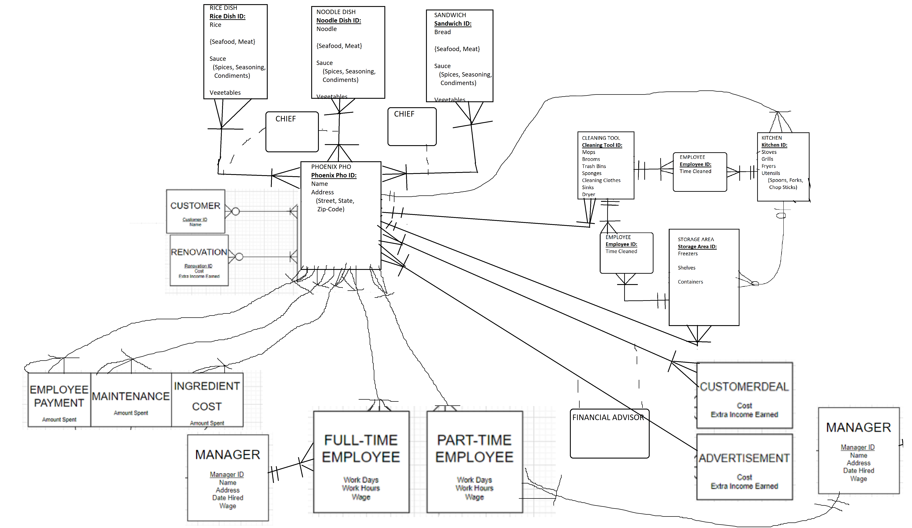

**EERD MODEL:**

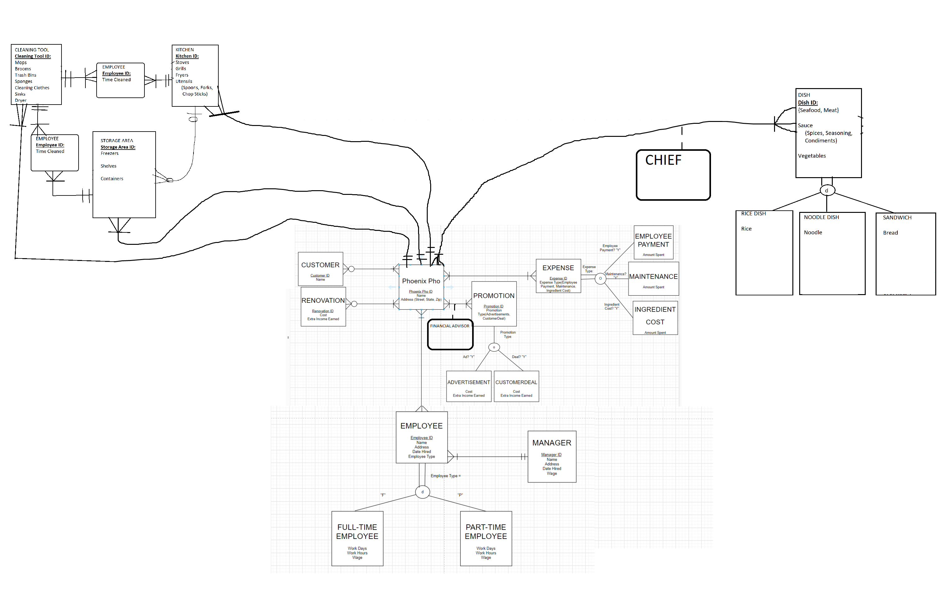

**Data Model:**

